**DAY 4 – CLASS EXERCISES**

**CLASS EXERCISE 1**

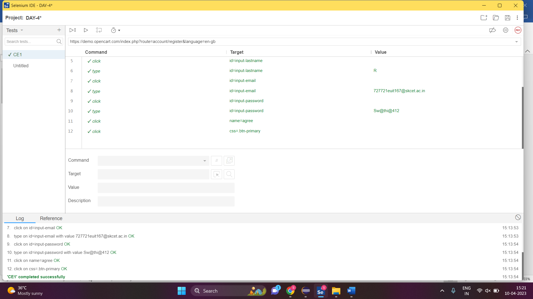

**CLASS EXERCISE 2**

**package** com.softwaretest1.demo1;

**import** org.openqa.selenium.By;

**import** org.openqa.selenium.WebDriver;

**import** org.openqa.selenium.WebElement;

**import** org.openqa.selenium.chrome.ChromeDriver;

**import** org.openqa.selenium.chrome.ChromeOptions;

**import** io.github.bonigarcia.wdm.WebDriverManager;

**public** **class** App

{

**public** **static** **void** main( String[] args ) **throws** InterruptedException

{

WebDriverManager.*chromedriver*().setup();

ChromeOptions co=**new** ChromeOptions();

co.addArguments("--remote-allow-origins=*");

WebDriver driver=**new** ChromeDriver(co);

driver.get("https://demo.opencart.com/index.php?route=account/register&language=en-gb");

driver.manage().window().maximize();

WebElement fname=driver.findElement(By.*id*("input-firstname"));

fname.sendKeys("Swathi");

WebElement lname=driver.findElement(By.*xpath*("//input[@id=\"input-lastname\"]"));

lname.sendKeys("R");

WebElement email=driver.findElement(By.*cssSelector*("input#input-email"));

email.sendKeys("swathiravikumar2003@gmail.com");

driver.findElement(By.*id*("input-password")).sendKeys("swathi@123");

Thread.*sleep*(3000);

driver.findElement(By.*xpath*("//*[@id=\"input-newsletter-yes\"]")).click();

}

}

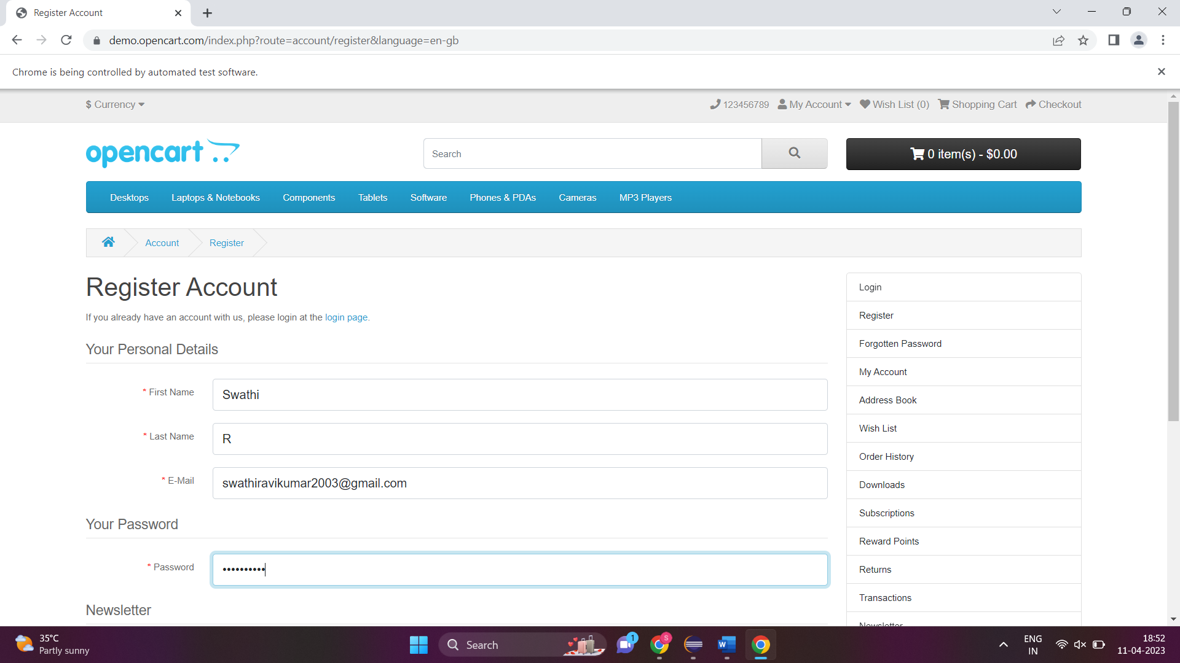

**CLASS EXERCISE 3**

**package** com.softwaretest1.demo1;

**import** org.openqa.selenium.By;

**import** org.openqa.selenium.WebDriver;

**import** org.openqa.selenium.chrome.ChromeDriver;

**import** org.openqa.selenium.chrome.ChromeOptions;

**import** io.github.bonigarcia.wdm.WebDriverManager;

**public** **class** CE3 {

**public** **static** **void** main(String[] args) {

WebDriverManager.*chromedriver*().setup();

ChromeOptions co=**new** ChromeOptions();

co.addArguments("--remote-allow-origins=*");

WebDriver d=**new** ChromeDriver(co);

d.get("https://demo.opencart.com/index.php?route=checkout/voucher&language=en-gb");

d.manage().window().maximize();

d.findElement(By.*xpath*("//input[@id=\"input-to-name\"]")).sendKeys("Niranj");

d.findElement(By.*xpath*("//input[@id=\"input-to-email\"]")).sendKeys("niranj@gmail.com");

d.findElement(By.*xpath*("//input[@id=\"input-from-name\"]")).sendKeys("Swathi");

d.findElement(By.*xpath*("//input[@id=\"input-from-email\"]")).sendKeys("swathu@gmail.com");

d.findElement(By.*xpath*("//input[@id=\"input-theme-7\"]")).click();

d.findElement(By.*xpath*("//textarea[@id=\"input-message\"]")).sendKeys("Happy Birthday !!!");

d.findElement(By.*xpath*("//*[@id=\"form-voucher\"]/div[8]/div/div/input")).click();

d.findElement(By.*xpath*("//*[@id=\"form-voucher\"]/div[8]/div/button")).click();

}

}

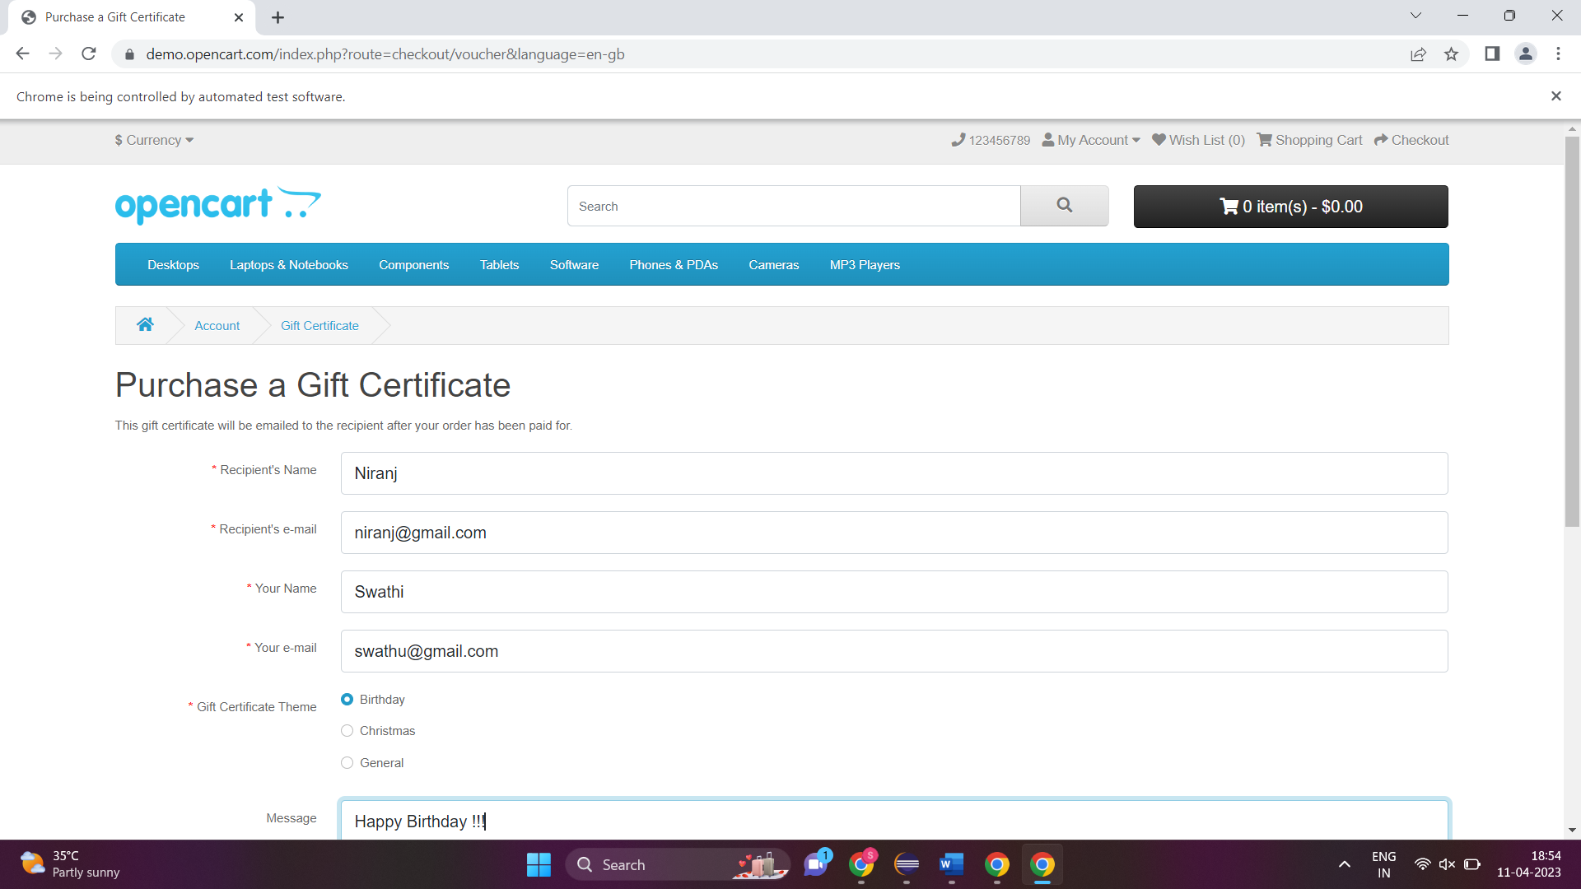

**CLASS EXERCISE 4**

**package** com.softwaretest1.demo1;

**import** org.openqa.selenium.By;

**import** org.openqa.selenium.WebDriver;

**import** org.openqa.selenium.chrome.ChromeDriver;

**import** org.openqa.selenium.chrome.ChromeOptions;

**import** io.github.bonigarcia.wdm.WebDriverManager;

**public** **class** CE4 {

**public** **static** **void** main(String[] args) {

WebDriverManager.*chromedriver*().setup();

ChromeOptions co=**new** ChromeOptions();

co.addArguments("--remote-allow-origins=*");

WebDriver d=**new** ChromeDriver(co);

d.navigate().to("https://j2store.net/free/");

d.manage().window().maximize();

d.findElement(By.*xpath*("//*[@id=\"Mod112\"]/div/div/ul/li[1]/h4/a")).click();

d.navigate().back();

d.navigate().forward();

d.navigate().refresh();

d.close();

}

}

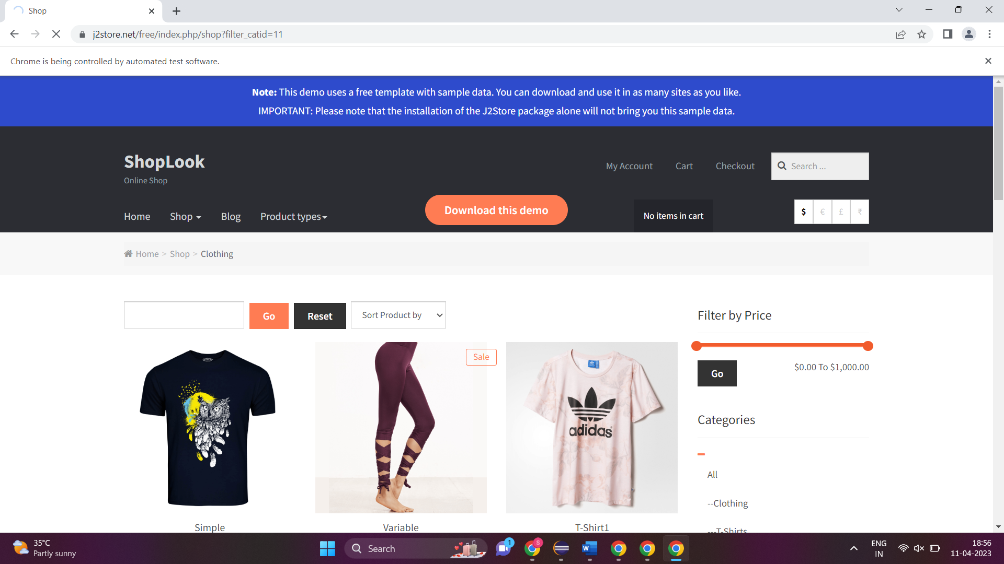

**CLASS EXERCISE 5.1**

**package** com.softwaretest1.demo1;

**import** org.openqa.selenium.By;

**import** org.openqa.selenium.WebDriver;

**import** org.openqa.selenium.chrome.ChromeDriver;

**import** org.openqa.selenium.chrome.ChromeOptions;

**import** io.github.bonigarcia.wdm.WebDriverManager;

**public** **class** CE5_01 {

**public** **static** **void** main(String[] args) {

WebDriverManager.*chromedriver*().setup();

ChromeOptions co=**new** ChromeOptions();

co.addArguments("--remote-allow-origins=*");

WebDriver d=**new** ChromeDriver(co);

d.get("https://j2store.net/free/");

d.manage().window().maximize();

String currentURL=d.getCurrentUrl();

d.findElement(By.*xpath*("//*[@id=\"Mod112\"]/div/div/ul/li[1]/h4/a")).click();

String expectedUrl="https://j2store.net/free/";

**if**(currentURL.equals(expectedUrl)) {

System.***out***.print("URL MATCHED");

}

**else** {

System.***out***.print("URL NOT MATCHED");

}

}

}

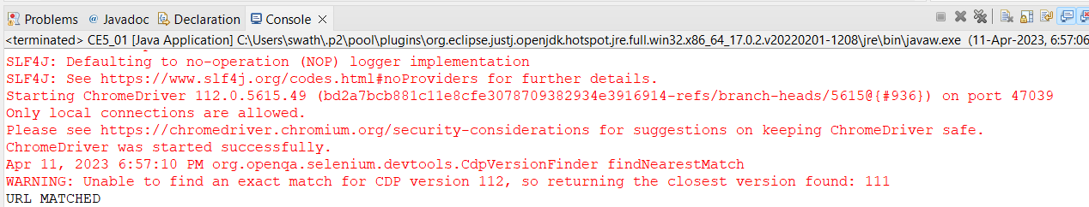

**CLASS EXERCISE 5.2**

**package** com.softwaretest1.demo1;

**import** java.util.List;

**import** org.openqa.selenium.By;

**import** org.openqa.selenium.JavascriptExecutor;

**import** org.openqa.selenium.WebDriver;

**import** org.openqa.selenium.WebElement;

**import** org.openqa.selenium.chrome.ChromeDriver;

**import** org.openqa.selenium.chrome.ChromeOptions;

**import** io.github.bonigarcia.wdm.WebDriverManager;

**public** **class** CE5_02 {

**public** **static** **void** main(String[] args) {

WebDriverManager.*chromedriver*().setup();

ChromeOptions co=**new** ChromeOptions();

co.addArguments("--remote-allow-origins=*");

WebDriver d=**new** ChromeDriver(co);

d.get("https://j2store.net/free/");

d.manage().window().maximize();

JavascriptExecutor js=(JavascriptExecutor) d;

js.executeScript("window.scrollBy(0,1000)", "");

d.findElement(By.*xpath*("//*[@id=\"Mod112\"]/div/div/ul/li[1]/h4/a")).click();

List <WebElement> product=d.findElement(By.*xpath*("//a[@itemprop=\"url\"]"));

List <WebElement> li=d.findElements(By.*xpath*("//h2[@itemprop=\"name\"]"));

**for**(WebElement link:li) {

System.***out***.println(link.getText());

}

}

}

